Data Structure and Algorithm
Laboratory Activity No. 14

Tree Structure Analysis

Submitted by: | Instructor:
Hermosura, Leigh B. | Engr. Maria Rizette H. Sayo

November 9, 2025

Objectives
Introduction
An abstract non-linear data type with a hierarchy-based structure is a tree. It is made up of links connecting nodes (where the data is kept). The root node of a tree data structure is where all other nodes and subtrees are connected to the root.

This laboratory activity aims to implement the principles and techniques in:
- To introduce Tree as Non-linear data structure
- To implement pre-order, in-order, and post-order of a binary tree
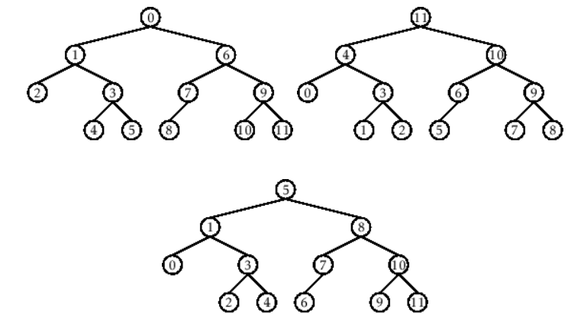

- Figure 1. Pre-order, In-order, and Post-order numberings of a binary tree

Methods
  - Copy and run the Python source codes.
  - If there is an algorithm error/s, debug the source codes.
  - Save these source codes to your GitHub.
  - Show the output

    - Tree Implementation

class TreeNode:
def __init__(self, value):
self.value = value
self.children = []

def add_child(self, child_node):
self.children.append(child_node)

def remove_child(self, child_node):
self.children = [child for child in self.children if child != child_node]

def traverse(self):
nodes = [self]
while nodes:
current_node = nodes.pop()
print(current_node.value)
nodes.extend(current_node.children)

def __str__(self, level=0):
ret = " " * level + str(self.value) + "\n"
for child in self.children:
ret += child.__str__(level + 1)
return ret

# Create a tree
root = TreeNode("Root")
child1 = TreeNode("Child 1")
child2 = TreeNode("Child 2")
grandchild1 = TreeNode("Grandchild 1")
grandchild2 = TreeNode("Grandchild 2")

root.add_child(child1)
root.add_child(child2)
child1.add_child(grandchild1)
child2.add_child(grandchild2)

print("Tree structure:")
print(root)

print("\nTraversal:")
root.traverse()

Questions:
- What is the main difference between a binary tree and a general tree?
- In a Binary Search Tree, where would you find the minimum value? Where would you find the maximum value?
- How does a complete binary tree differ from a full binary tree?
- What tree traversal method would you use to delete a tree properly? Modify the source codes.

Results
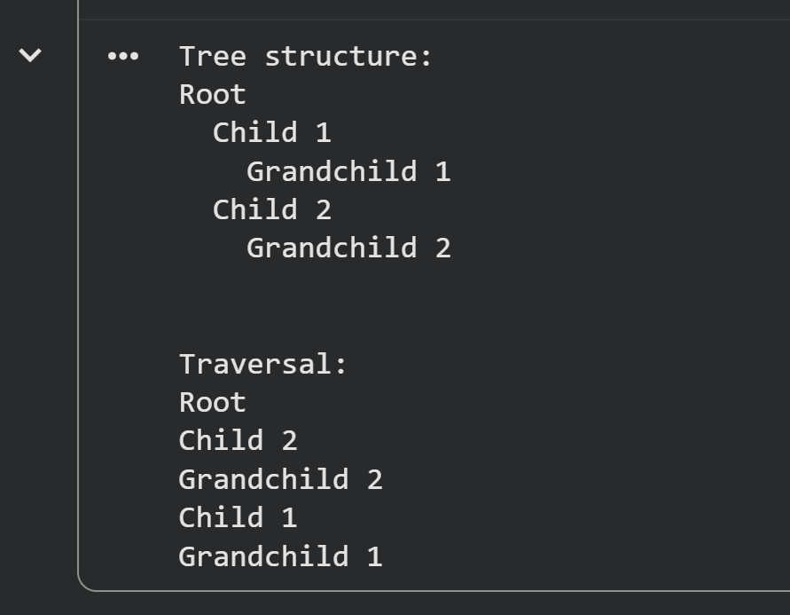
Figure 1 Output of the Code

- What is the main difference between a binary tree and a general tree?
- A general tree can have many or zero child nodes but it cannot be empty. There is no limit to how large the degree of the node is and its nodes cannot be ordered according to a specific criteria. A binary tree on the other hand must have two child nodes at most per node. Unlike the general tree, a binary tree can be empty and it’s ordered to accoring to a specific criteria [1].

- In a Binary Search Tree, where would you find the minimum value? Where would you find the maximum value?
- In a Binary Search Tree the lowest value is found at the leftmost node whilst the highest value is found at the rightmost node [2].

- How does a complete binary tree differ from a full binary tree?
- A full binary tree must only have zero or two child nodes. A complete binary tree has all of its levels filled to the maximum number of possible nodes except the last level. The last level must have it’s nodes appear furthest to the left as possible [3].

- What tree traversal method would you use to delete a tree properly? Modify the source codes.
- I would use the post-order traversal method to delete the children nodes first before deleting the parent node [4].

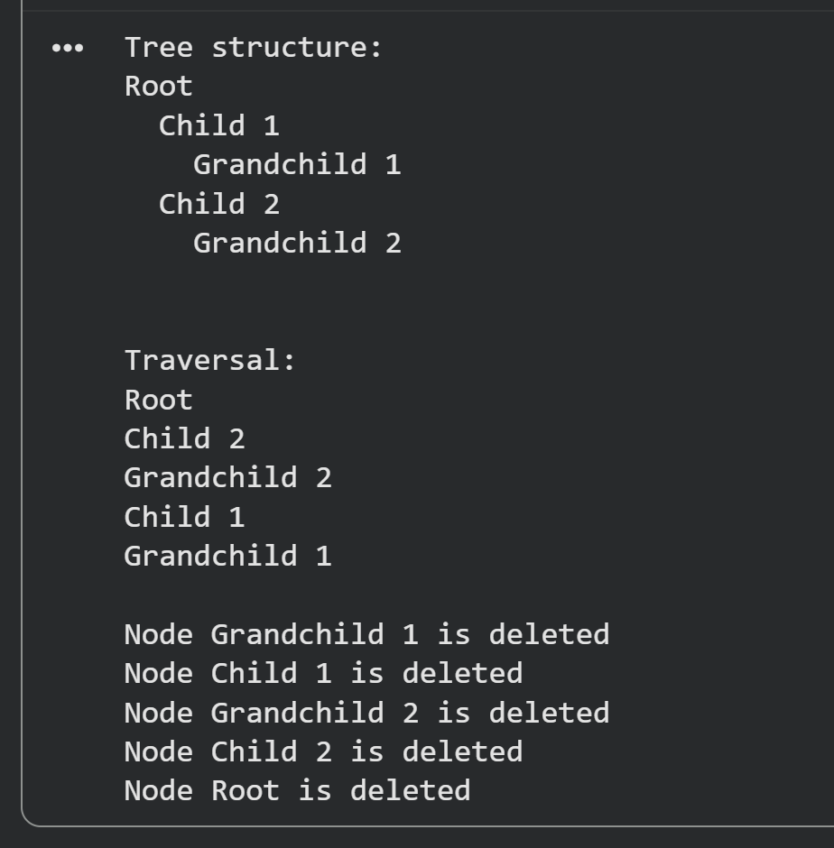
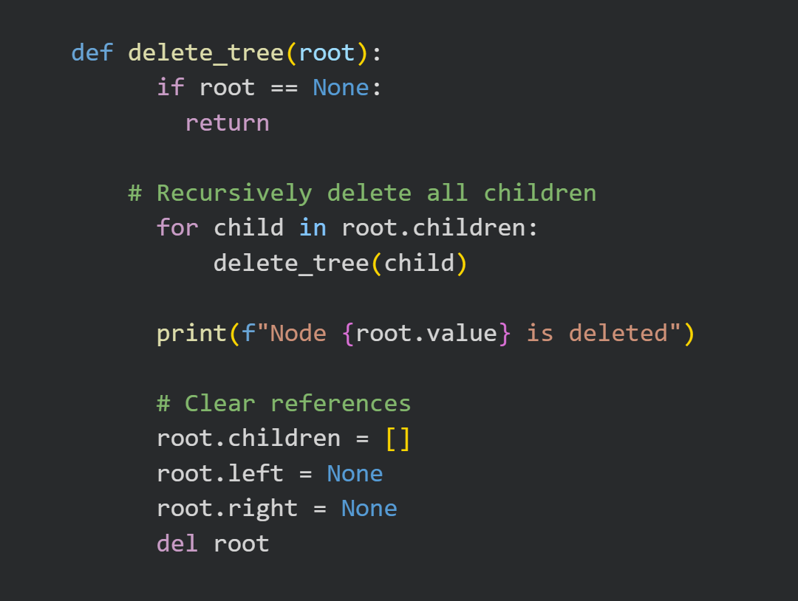
Figure 2 Function for Deleting the Tree Figure 3 Output of Deleting the Tree

Conclusion
The conclusion expresses the summary of the whole laboratory report as perceived by the authors of the report.

References
[1] GeeksforGeeks, “Difference between General tree and Binary tree,” GeeksforGeeks, Oct. 10, 2019. https://www.geeksforgeeks.org/dsa/difference-between-general-tree-and-binary-tree/ (accessed Nov. 09, 2025).
[2] “Find maximum (or minimum) in Binary Tree,” GeeksforGeeks, Apr. 09, 2015. https://www.geeksforgeeks.org/dsa/find-maximum-or-minimum-in-binary-tree/ (accessed Nov. 09, 2025).‌
[3] GeeksforGeeks, “Difference between Full and Complete Binary Tree,” GeeksforGeeks, Apr. 06, 2022. https://www.geeksforgeeks.org/dsa/difference-between-full-and-complete-binary-tree/ (accessed Nov. 09, 2025).
[4] GeeksforGeeks, “Write a program to Delete a Tree,” GeeksforGeeks, Jun. 27, 2009. https://www.geeksforgeeks.org/dsa/write-a-c-program-to-delete-a-tree/ (accessed Nov. 09, 2025).
‌

